**Project Initiation Document**

|  |  |
| --- | --- |
| **Project stage** | Delivery |
| **Document Type** | Project Initiation Document (PID) |
| **Project No.** |  |
| **Project Name** | Unitary MailBot – The next phases |
| **Audience for this document** | |
| SRO, Programme Board, PMO | |
| **Purpose of this document** | |
| A PID is not necessarily a single document; it is usually a *collection* of important project documents. It is designed to bring together the key information needed to start the project on a sound basis, and to communicate that information to everyone involved with the project. It is used to gain authorisation from the Programme Board for the project to go ahead. Version history must be retained and prior copies retained to provide an audit trail. | |

|  |  |  |  |
| --- | --- | --- | --- |
| **Version History** | | | |
| **Date** | **Version** | **Author** | **Brief Comments on Changes** |
| 17/05/2021 | 0.1 | Gifty Beckley | Document created |
|  |  |  |  |

|  |  |
| --- | --- |
| **Distribution (For Information, Review or Approval)** | |
| **Name** | **Resp(1)** |
|  | R/ A /I |
|  |  |

(1) Responsibility: R=Review, A=Approval, I=Information

|  |  |
| --- | --- |
| **Document Approval** | |
| **Date** | **Who** |
|  |  |

|  |
| --- |
| **1. Business Challenge/Opportunity** |

The Unitary MailBot Project begun under the Future Northants unitary email project where the

first phase of the Unitary MailBot was delivered to enable a safe and legal implementation.

Please find the PID for this here:



The unitary email handling options paper documented additional stages and options for the

development of the MailBot that will enable customer service teams to realise efficiencies and

savings of £300k. There is an opportunity to pursue the development of those additional stages

in order to maximise the efficiencies that the MailBot can provide along with projected savings.

The options that were presented in the paper can be broken down into three distinct phases.

Please see the diagram below:

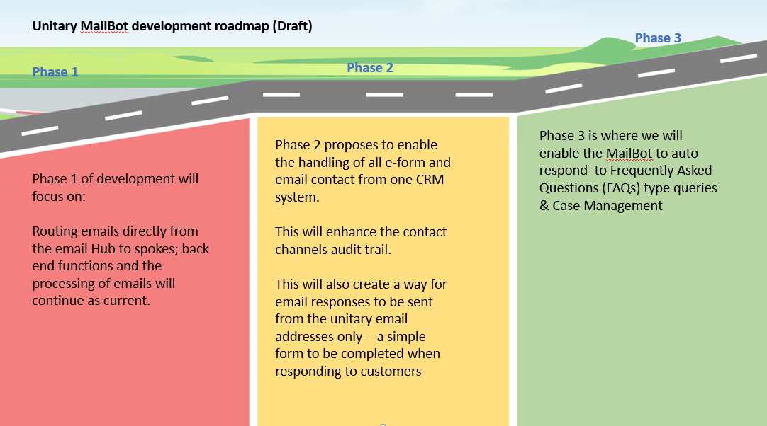

As mentioned earlier, phase 1 has been delivered and the purpose of this new project is to deliver phase 2 and 3.

|  |  |
| --- | --- |
| **2. Business Case** | YES/NO |
| If a Business Case has been completed please refer to that document for further details. If a Business Case hasn’t been completed see below for business case details. | Yes – an options appraisal has been produced |

|  |
| --- |
| **3. Objectives** |

1. To enable e-contact forms and emails to become a more efficient channel for customers to use
2. To enable e-contact forms and emails to become a more efficient channel to manage for North Northamptonshire Council and West Northamptonshire Council customer service teams
3. To automate the handling of some customer queries received by e-form and email
4. To deliver savings to customer services department

|  |
| --- |
| **4. Deliverables and scope** |

* Develop enhancements to phase 1 of the MailBot implementation
* To move the North version of the MailBot onto the North Amazon Web Services account
* Carry out a review of the proposed additional MailBot phases
* Establish and develop appropriate processes for the additional MailBot phases
* Gather and document additional MailBot requirements
* Develop MailBots knowledgebase
* MailBot response database
* Testing of new MailBot developments
* Project benefits realisation planning, tracking and reporting
* Customer feedback plan

|  |
| --- |
| **6. Exclusions from Scope** |

The below is excluded from the scope of the project: TBC

|  |
| --- |
| **7. Constraints** |

Scope – as specified above

Timeline: April 2021 – April 2022

Budget: £27,000

|  |
| --- |
| **8. Assumptions** |

* The existing unitary MailBot project team will continue to work on the project
* There are some repetitive customer queries where it would be appropriate to provide a standard response
* The original budget allocated for the project from BRR funding is still available for use

|  |
| --- |
| **9. Interfaces and Dependencies** |

* Unitary e-forms platform
* Availability of project team to work on the project
* Chatbot project
* Virtual council project
* New North and West unitary transformation programmes
* Database of unitary Frequently Asked Questions and Answers

|  |
| --- |
| **10. Approach** |

The project will be managed using a blend of Prince 2 and agile project management. This has ensured completion of the business case and planning stage before proceeding to the implementation stage.

The agile methodology will be best at the implementation stage of the project - at this stage:

* Analysis will be done to understand the functionality that needs to be built into the bots and

how it needs to work for each user

* The bots will be developed (built)
* Internal testing will be carried out
* The bots will go live to be piloted

The Mailbot needs to be created in iterations via constant feedback from users and to enable

maximum collaboration across the project team in order to deliver the functionalities.

Constant feedback from the Product Owners will also be required at these stages.

|  |
| --- |
| **11. Outline Project Plan** |

* Develop enhancements to phase 1 of the MailBot implementation April 2021

– July 2021

* Carry out a review of the proposed additional MailBot phases May 2021 – June 2021
* To move the North version of the MailBot onto NNC Amazon Web Services account June 2021
* Project benefits realisation planning, tracking and reporting June 2021 – July 2021

(then on-going)

* Establish and develop appropriate processes for the next MailBot phase June – July 2021
* Gather and document additional MailBot requirements for the next phase – June – August 2021
* Develop MailBots knowledgebase/ database (timeline dependent on phase)
* Build agreed next phase of the MailBot July 2021 – October 2021
* Testing of new MailBot developments July 2021 – October 2021
* Customer feedback plan – July – August 2021
* Plan final phase September 2021
* Deliver final phase – November 2021

|  |
| --- |
| **12. Organisation, Roles and Responsibilities** |

|  |  |  |
| --- | --- | --- |
| **Role** | **Responsibility** | **Named individual** |
| Senior Responsible Officer | Overall accountability for the project. | TBC |
| Programme Manager | Oversees the programme | TBC |
| Project Manager | Manage, monitor and assist project delivery | Gifty Beckley |
| PMO Governance and Assurance officer | Providing project quality assurance to the transformation board  Tracking project progress | TBC |
| Project Support Officer | Providing the day-to-day support on the project | TBC |
| West Northamptonshire Council Product owner/ Senior User | To represent the customer to the development team. To be available to the development team to answer any questions team members have regarding the customer’s view of how they’re implementing a product feature. | Geraldine Mahney |
| North Northamptonshire Council Product owner/ Senior User | To represent the customer to the development team. To be available to the development team to answer any questions team members have regarding the customer’s view of how they’re implementing a product feature. | Joanne Young |
| Senior supplier | To design, develop, facilitate and implement the Mailbot. Will provide supplier resources to the project and ensure that the right people, tools, equipment and knowledge are in place, and that the products will meet the expected criteria, including quality criteria. | Digital team – headed by Kiri Crequer |
| MailBot project contact centre liaison for the North and quality assurance | To liaise with the contact centre leads and stakeholders in North Northants to gain consensus on ways of working and working closely with the BA. Ensures that the final product observes the expected quality standards for North Northants. | Marie Illingworth |
| Business Analyst (North and West) | Responsible for understanding business change needs, assessing the business impact of those changes, capturing, analysing and documenting requirements and supporting the communication and delivery of requirements with relevant stakeholders | Megan Crowthers |
| Scrum team | The collection of individuals working together to deliver the required product increments and phases for the MailBot. | North Northants - Kevin White, Andy Boatwright, Luke Barker, Joshua White, Megan Crowthers, Joanne Young, Marie Illingworth, Sadie Hodgson, Leeanne Fayter, Kelly Whitworth, Ket Jiang  West Northants - Kevin White, Andy Boatwright, Luke Barker, Joshua White, Megan Crowthers, Geraldine Mahney, Ken McAlindon, Savannah Aslin |
| Subject Matter Experts | Providing expert advice to the project | Amanda Davis, Kirsty Warren, Fran Frohawk, Liz Barrett / Shaun Taylor, Andy Cosford, Jan Pearey, Simon Mills |
| Project board | Directing the project, change authority and project assurance | TBC: |

|  |
| --- |
| **13. Project Controls** |

In ensuring the successful delivery of the MailBot project, the following project controls will be in place:

|  |  |  |  |  |
| --- | --- | --- | --- | --- |
| **Controls** | **Description** | **Stage** | **Dependency** | **Product** |
| Business Case/ Options appraisal | Justification for authorizing the project | Full business case | Evidence of project costs and benefits | Authorize Project |
| Project Initiation Document (PID) | Outlining the objectives, aims and project approach, project team, project controls and reporting | Delivery | Project authorisation  Business case | Initiate project |
| Stakeholder Analysis | Identifying key stakeholders (invested interest, influence and importance, stakeholder buy-in and relation management | Delivery |  | Stakeholders Matrix, Buy in and management |
| Communication Plan (RACI) | Framework for  managing the  exchange of  information within  the project and with all stakeholders | Strategize and Initiate & updated at end of each stage | Stakeholder Analysis | RACI Matrix and Communication Plan |
| Project Plan | A formal document designed to guide the control, management and execution of a project on daily basis (timeline, tolerance, dependencies, milestones, stages, tasks, deliverables) | Delivery / updated throughout project life cycle | Signed off Business Case & PID | Project status  Progress reporting (highlight report) |
| Risk and Issue log | Logging, tracking, monitoring and managing all risks and issues associated to the project | Managed throughout the project life cycle and updated at the end of each stage | Day to day project activities, external and internal factors | Risks and issues log |
| Authorize Project Closure | Authorize the completion of project and closing of project | Closing the project | Signed off – acceptance criteria met / expectations met / follow on recommendations | End Project Report & Follow On Recommendation |

|  |
| --- |
| **14. Project Tolerances** |

TBC

|  |
| --- |
| **15. Quality Controls** |

* Go live after testing
* Responding to feedback
* All identified Must have requirements must be met
* Identified Should and or Could have requirements will be met if time and budget permits
* Acceptance criteria to be established for each requirement and development work to be tested against this

|  |
| --- |
| **16. Risks and Issues** |

Risks:

It may not be appropriate to proceed with original phases of the unitary MailBot

|  |  |  |
| --- | --- | --- |
| **Risk description​** | **Impact​** | **Mitigation​** |
| Since the MailBot has gone live there are high numbers of customer email queries awaiting location confirmation in order to be processed. | We are unaware if these customers are still awaiting a service and if they are we could receive complaints. | Investigate the cases further by contacting customers if required to check why they did not respond. Consider further promoting the use of contact forms on the website and potentially removing West Northants email address from the website to avoid the need to request location information. |
| There is a risk that the MailBot performance cannot be monitored to the degree required. | Service levels to customers cannot be monitored. | Improve reporting capabilities – this is being worked on now. |
| There could be delays to resolving customer queries if current bugs are not resolved speedily. | Contact will not be handled in the most efficient way and customers could experience delays in receiving a response to their query. | Focus on resolving bugs before completing further development work on the project. |
| There is a risk that the MailBot will not be fully utilized to bring about the project benefits and efficiencies identified if further development is not completed.  ​ | Expected efficiencies will not be created. | 1. Continue development of the MailBot and create a plan to implement the additional phases of the project that will deliver efficiencies. 2. Work with the transformation Tean to ensure that the opportunities are identified throughout the unitary and efficiencies achieved. |

|  |
| --- |
| **17. Communication** |

A communications plan will be developed for the project (to include plans for a show and tell).

|  |
| --- |
| **18. Change Management** |

Consultation and engagement with contact centres required as well as customers. Plan to be

developed to include product demos.